**Method Description for OpenCloseFists/Feet**

This study implements EEGNet (Lawhern et al.), a compact convolutional neural network architecture specifically designed for EEG-based brain-computer interfaces, to perform binary classification on electroencephalogram (EEG)d during open/closed fists/feet movement tasks. Two-channel EEG data from TP9 and TP10 electrode positions are preprocessed using a sliding window approach with a window size of 1024 samples and 80% overlap to generate training segments. The EEGNet architecture consists of three main processing blocks: (1) a temporal convolution block with 8 filters and kernel length of 64 samples to learn frequency-specific temporal patterns across the time domain; (2) a depthwise spatial convolution block that applies spatial filtering to each temporal feature map, followed by batch normalization, ELU activation, average pooling (factor of 4), and dropout regularization; and (3) a separable convolution block with 16 filters that efficiently combines spatial-temporal features, followed by batch normalization, ELU activation, average pooling (factor of 8), and dropout. The extracted features are then passed through a fully connected classification layer with max-norm weight constraint regularization. The model processes input data in the format (batch_size, 1, 2, 1025) to accommodate the two-channel EEG configuration. Training employs binary cross-entropy loss with class balancing, Adam optimization with learning rate scheduling using ReduceLROnPlateau, and applies EEGNet-specific max-norm constraints to prevent overfitting. Model evaluation includes standard classification metrics (precision, recall, F1-score), confusion matrix analysis, and ROC curve assessment to evaluate the model's ability to distinguish between resting state and open/closed fist actions.

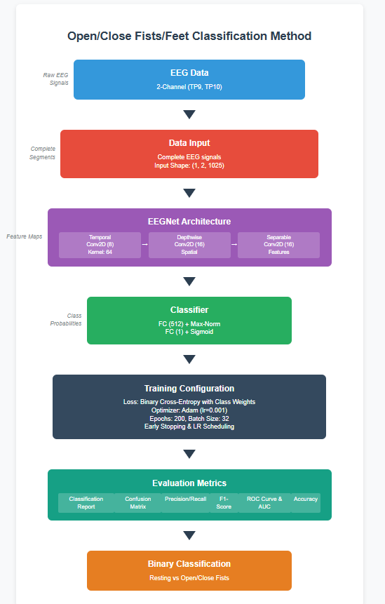

Figure 1: Open/Close Fists/Feet Classification Methods

Figure 2: Model Performance on Resting vs. Open/Close Fists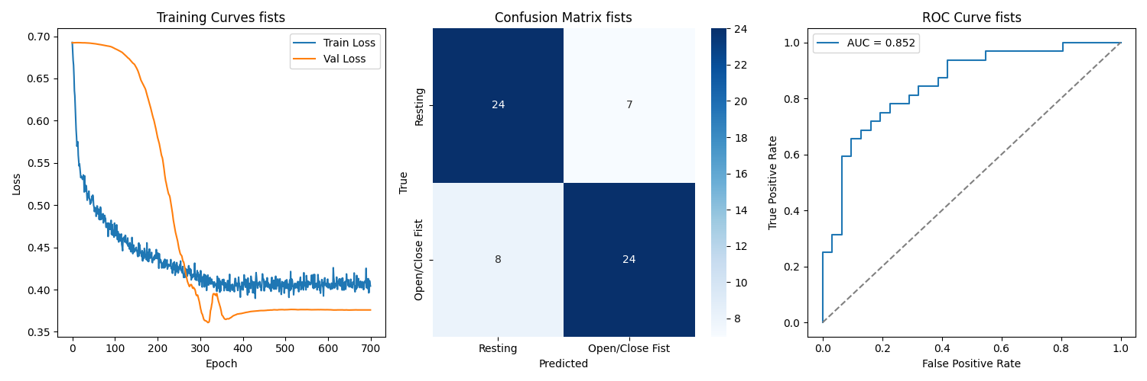

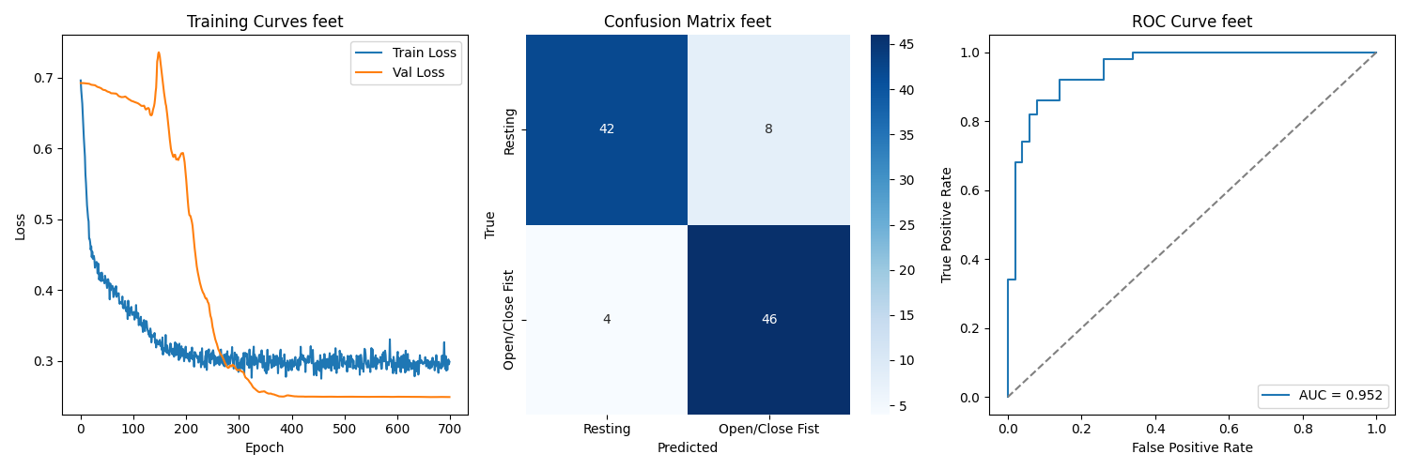

Figure 3: Model Performance on Resting vs. Open/Close Feet

**Reference**

Lawhern, V. J., Solon, A. J., Waytowich, N. R., Gordon, S. M., Hung, C. P., & Lance, B. J. (2018). EEGNet: A compact convolutional neural network for EEG-based brain-computer interfaces. *Journal of Neural Engineering*, 15(5), 056013.<https://doi.org/10.1088/1741-2552/aace8c>